PE

Year 2 have PE on a Monday and Tuesday afternoon. This half term the children will develop gymnastic skills and games. Please ensure your child has their PE kit in school on these days. Children with long hair should have it tied back and earrings must be removed by the child or before school.

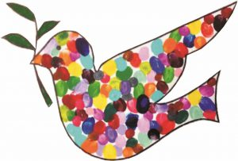

Curriculum on a Page for Parents

Year 2

Summer Term 1

Homework

Pupils receive homework every Friday. This includes:

* learning the weekly spellings
* reading at home at least five times a week and having their planner signed.
* Times Table Rock Stars
* Numbots

Homework needs to be returned by the following Friday when this will be marked in class.



Extra Excitement!

This term the children will celebrate the coronation with a ‘street’ party and have the chance to go on an educational visit. More information to follow!

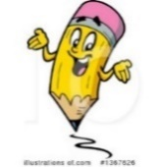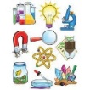

Science

This half term your child will identify whether things are alive, dead or have never lived. They will name different plants and animals and describe how they are suited to different habitats. They will discover how different habitats provide for the basic needs of different kinds of animals and plants, and how they depend on each other. Describe how animals obtain their food from plants and other animals, using the idea of a simple food chain.

Writing

Your child will explore texts so they

can write their own twist on a traditional tale. They will learn to use description to develop settings. They will develop their vocabulary through the use of persuasive language to write a persuasive letter. Spellings will be tested the following Friday.

Reading 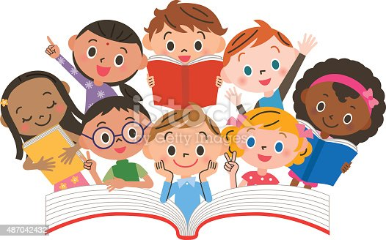

Twice a week your child will read a book with an adult in a small group which is matched to their reading ability. They will develop skills in decoding, prosody and comprehension.

A home reading book will be sent home for your child to read with you. Please sign their reading record to show they have read. Children will learn the common exception words for Year 2. These words are found listed in the planner to practice at home.

PSHE

Our PSHE unit this half term is called Money Matters. Your child will continue to recognising what money looks like, identifying how money is obtained and the ways money can be used. They will develop an understanding of how to keep money safe and what influences choices.

 History

This half term your child will explore local history through a topic about the importance of pottery to the area.

They will learn about Wedgewood, Claris Cliff and the history of Sharpe’s Pottery in Swadlincote.

Maths

As mathematicians, we will learn to use standard units to measure length and height, mass, capacity and temperature.

They will learn about fractions as equal parts using halves, quarters and thirds. They will investigate simple equivalence and using fractions to make a whole.

We will continue to consolidate our basic arithmetic skills.

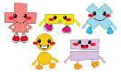

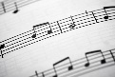

Music

Your child will learn about orchestral instruments and will identify instruments and sections of the orchestra. They will explain what is happening in the music using language relating to emotion. They will create a piece of music with some appropriate tempo, dynamic and timbre changes.

RE

This half term the children will to learn in depth from different religious and spiritual ways of life about caring for other people and for the world. Through studying Bible stories, the lives of believers such as Dr Barnardo, Mother Teresa or a local believer, the Jewish practice of Tzedakah and Sukkot celebrations pupils learn about how beliefs turn into actions for many religious and non-religious people.



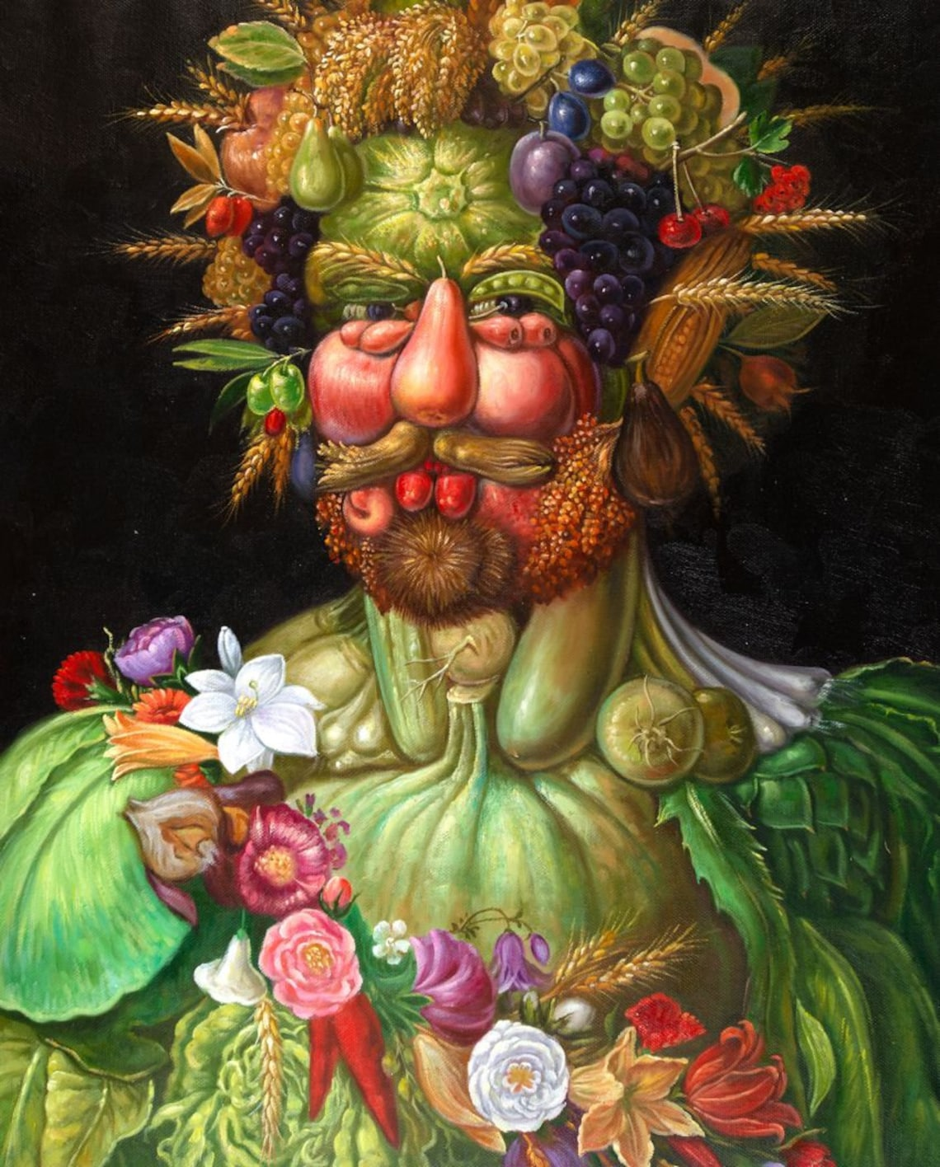 Art

This half term your child will explore and analyse ‘Nature art’ as a form of 3D art inspired by Land artist Andy Goldsworthy.

They will investigate work by Wedgewood and Claris Cliff anduse clay to make a pinch pot to explore pottery linked to our topic.