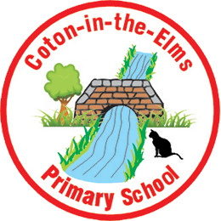
Remote Learning Guidance in case of School Closure.
Ideally staff will meet children on Teams.
Work can be set on Mirodo / TTRS/ Numbots.
Pupils each have their own email. Their login details are stuck in their pupil planners. Staff will email out the work, copying in the headteacher and the school office.
Alternatively links to websites and worksheets may be emailed out via the app.
Timetable for the day
- Meet children via Teams to talk through the tasks to be completed.
Year 5 and 6 – 8.50am
Year 4 – 9am
Year 2 and 3 – 9.10am
Reception and Year 1 – 9.20am
This should help in case siblings are having to share a device.

- Phonics - EYFS and KS1 –
Phonics lesson. Deliver a phonics lesson online or try and find an online lesson to share with children to watch. online phonics lessons little wandle - Bing video
Year 2 – 6 – a spelling activity linked to weeks spelling rule – use Twinkl or Grammarsaurus for activities. Spelling and Grammar, English Games for 7-11 Years - Topmarks
- SPaG/ reading comprehension
Grammarsaurus has lots of activities you can upload for children to access. Grammarsaurus - Resources from practising teachers and writing moderators
- Maths
Share the relevant video from White Rose along with the worksheet linked to this lesson.
Maths home learning | Home learning | White Rose Maths
Ask children to join you later in the day to mark their work with you (share the answers and take feedback on how they did).
- Storytime
Read a story to your class. There are online stories available here: Storyline Online - Home (for younger children really)
Useful websites to use for online teaching:
Oak National Academy Online Classroom (thenational.academy)
Primary Homework Help | Online Games For Kids - BBC Bitesize
Free Downloadable Activity Sheets for Kids | Learning Resources (good for EYFS)
- Meet your class at the end of the day via Teams for story time but also to review the work completed.

